**Decision Tree** is the most powerful and popular tool for classification and prediction. A Decision tree is a flowchart-like tree structure, where each internal node denotes a test on an attribute, each branch represents an outcome of the test, and each leaf node (terminal node) holds a class label. 6309820071

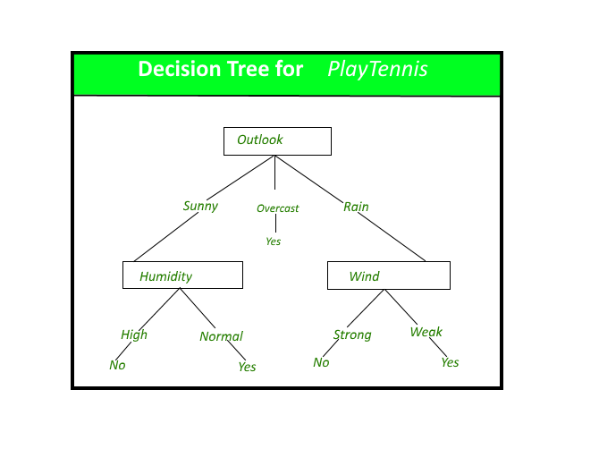A decision tree for the concept Play Tennis.

**Construction of Decision Tree:** A tree can be “learned” by splitting the source set into subsets based on an attribute value test. This process is repeated on each derived subset in a recursive manner called recursive partitioning. The recursion is completed when the subset at a node all has the same value of the target variable, or when splitting no longer adds value to the predictions. The construction of a decision tree classifier does not require any domain knowledge or parameter setting, and therefore is appropriate for exploratory knowledge discovery. Decision trees can handle high-dimensional data. In general decision tree, classifier has good accuracy. Decision tree induction is a typical inductive approach to learn knowledge on classification.

**Short note on Decision Tree: -**

* A decision tree, which is also known as prediction tree refers to a tree structure to mention the sequences of decisions as well as consequences.
* Considering the input X = (X1, X2,… Xn), the aim is to predict a response or output variable Y.
* Each element in the set (X1, X2,…Xn) is known as input variable. It is possible to achieve the prediction by the process of building a decision tree which has test points as well as branches.
* At each test point, it is decided to select a particular branch and traverse down the tree.
* Ultimately, a final point is reached, and it will be easy to make prediction.
* In a decision tree, all the test points exhibit testing specific input variables (or attributes), and the developed decision tree is represented by the branches.
* Because of flexibility as well as simple visualization, decision trees are mostly probably deployed in data mining applications for the purpose of classification.
* In the decision tree, the input values are considered as categorical or continuous.
* A structure of test points (known as nodes) and branches is established by the decision tree by which the decision being made will be represented.
* Leaf node is the one which does not have further branches. The returning value of leaf nodes is class labels while in some cases they return the probability scores.
* It is possible to convert a decision tree into a set of decision rules.
* There are two types of Decision trees: **classification trees and regression trees.**
* **Classification trees**are generally applied to output variables which are categorical and mostly binary in nature, for example yes or no, sale or not, and so on.
* Whereas **regression trees** are applied to output variables which are numeric or continuous, for example predicted price of a consumer good.
* In a variety of situations, it is possible to apply decision tree. It is easy to represent them in a visual way, and the analogous straightforward.
* Also, as the result is a sequence of logical if-then statements, there is not any presence of underlying assumption regarding a linear or nonlinear relationship between the input variables and the response variable.